VISUALIZATION TOOL FOR ELECTRIC VEHICLE CHARGE
AND RANGE ANALYSIS
Team ID : LTVIP2026TMIDS41011
Team Leader : Avanigadda Sayal
Team member : Kakarla Sandhya
Team member : Kalidindi Salma
Team member : Gutta Yashwanth

INTRODUCTION
Today the transport sector stands for roughly 60% of the global oil
consumption (IEA, 2010), and is attributable for roughly 20-25% of all CO2 emissions (EEA, 2011; IEA, 2009). A wide adaption of electric vehicles (EVs) could significantly lower the CO2 emissions (Reiner et al., 2010). A market that is therefore of great interest is the electric vehicle charging station (EVCS) market, it is growing at a rapid pace and there are as of today many different actors that are struggling to capture market segments (Pike Research 2011a), and gain customer loyalty. The current competitive situation for this market is not well defined within the company and therefore it is important to perform a competitor analysis to define the competitive situation (Porter, 2008)

1.1. OVERVIEW OF THE PROJECT
This report presents the findings from a competitor analysis involving competitor identification, understanding the competitors’ target customers, how they do business, and an assessment of competitors’ marketing material. This analysis of the competitive situation in the EVCS market is done in order to enhance the knowledge of possible competitors and their offers to the rapidly growing EVCS market. A brief market analysis is also performed to assess the potential of the EVCS market along with related market drivers and restraints, this to show the opportunities that the market presents .

1.2. PURPOSE
The main purpose of this project is to conduct a competitor analysis within the area of electric vehicle charging stations (EVCS) to increase the existing knowledge of possible competitors and their offers to the market. Prior to performing the competitor analysis a basic market analysis will be performed to assess the EVCS market. The research questions have been developed in cooperation with a company that has an interest in the EVCS market, and these questions are thus based on this company’s interests concerning the EVCS market and its competitors.
2 PROBLEM DEFINITION & DESIGN THINKING

2.2 IDEATION & BRAINSTORMING MAP

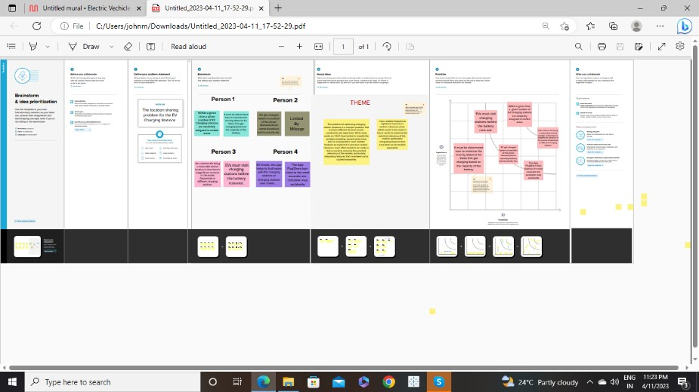
3.RESULT
1. Charging Stations by Region & Type in India
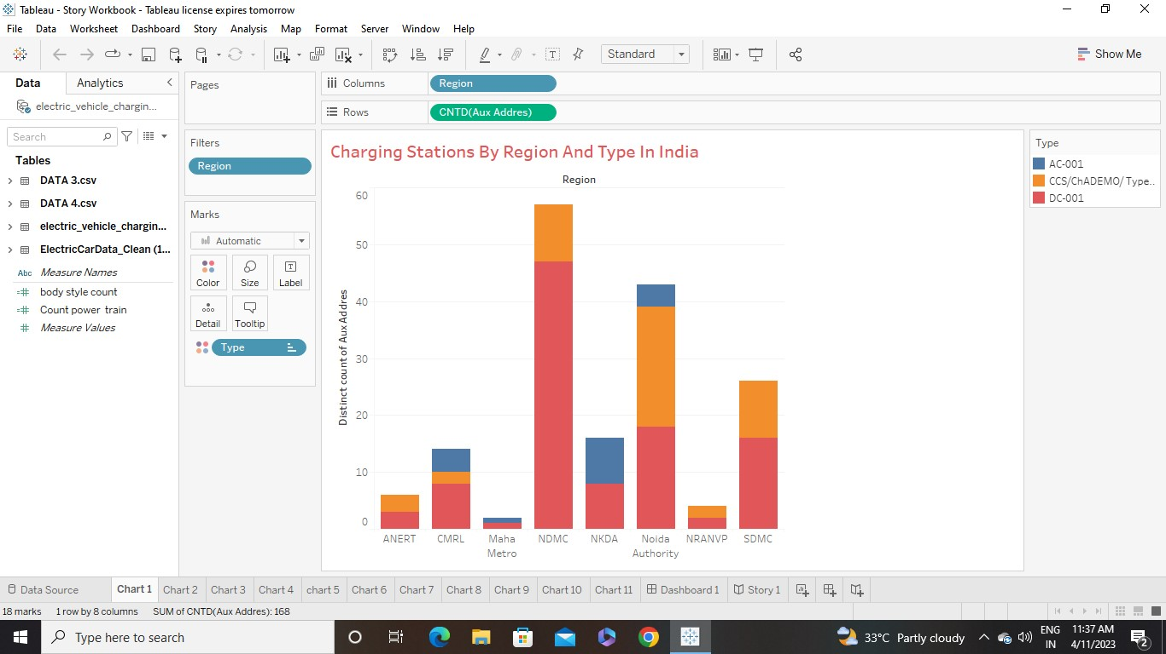
In the above chart we count Auxaddress to find in which region how many charging stations are there and what type.The result we get there are three types of charging stations are in india & region NDMC is highest.

2.EV Charging Stations Map of India
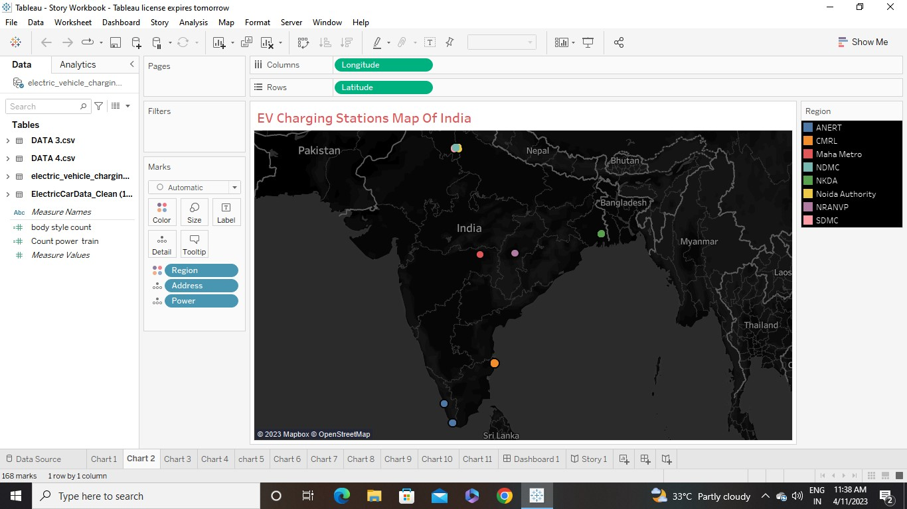
In this chart we plot the Charging Stations of India on the map. We also show that address, power & in which region the charging stations belongs to . It is clear that in North Delhi there are many Charging Stations.

3. Different EV Cars in India
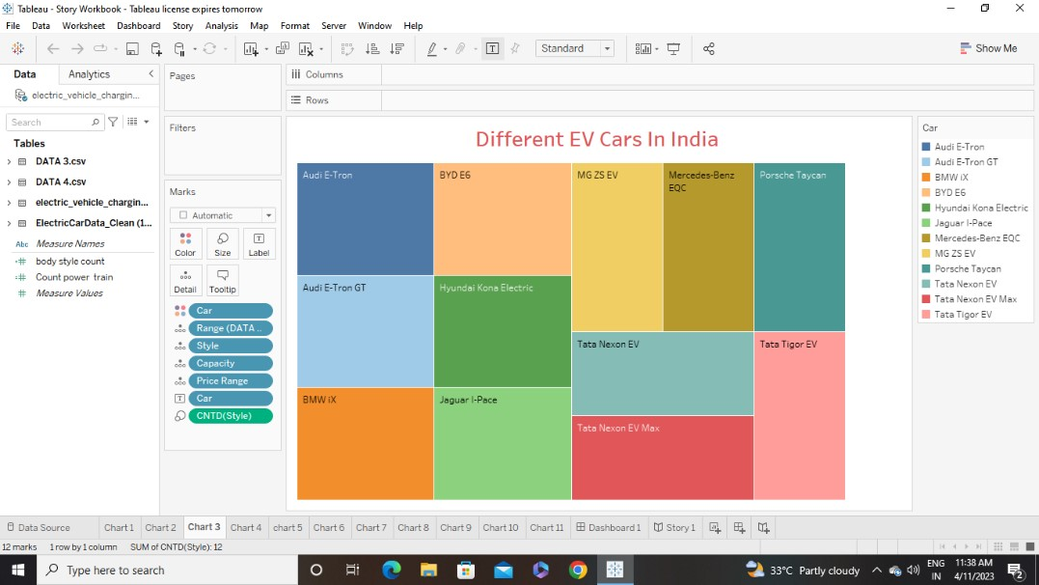
In this chart we show that What are the different models of the cars that are available in India with Car’s Style, Capacity, Range & Price range.

4.Top Speed for Different Brands
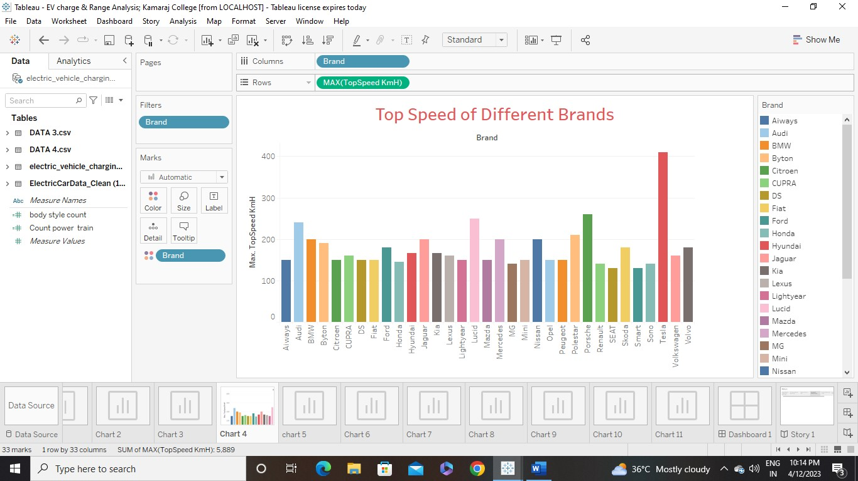
In this chart we show that Top speed of different brand in India. In this result we get Brand Tesla have the highest top speed among all the brands.

5.Price for different cars in India

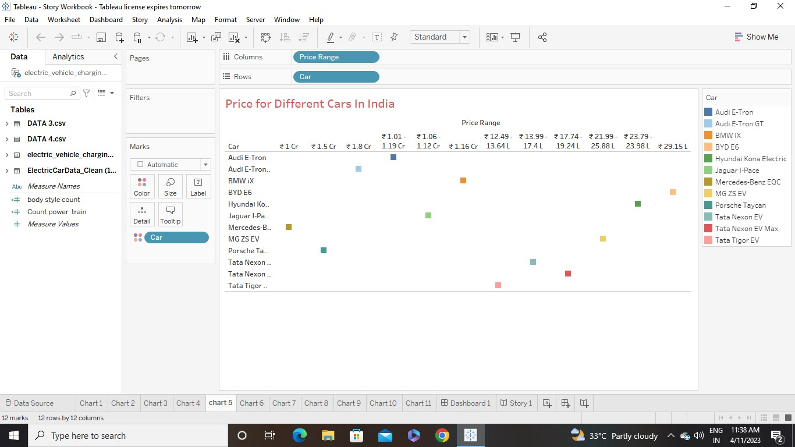
In this chart we show price for different cars in India
For that, we need sum of price range i.e, price range in measure values, But in our data we have price range in measure names so we are not able to change the price range to sum of price range. So we put the data as we have and get the above visualization result

6 Top 10 most efficient EV Brands
In this chart first we find the efficiency of the brands and then filter it to top 10 efficiency brands and get the result. Here, the most efficient brand is Mercedes

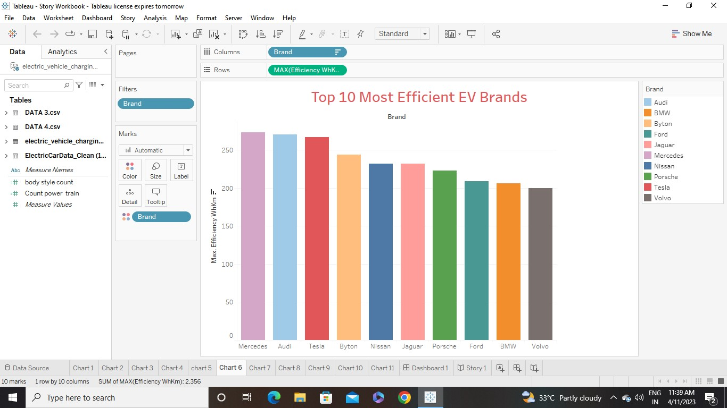

7. Brands according to Body Style


In this chart we count the body style for different brand, for that we create the calculation field to count bodystyle then we create a bubble chart , the size of the bubbles is according to the bodystyle

8. Brand filtered by Power Train type

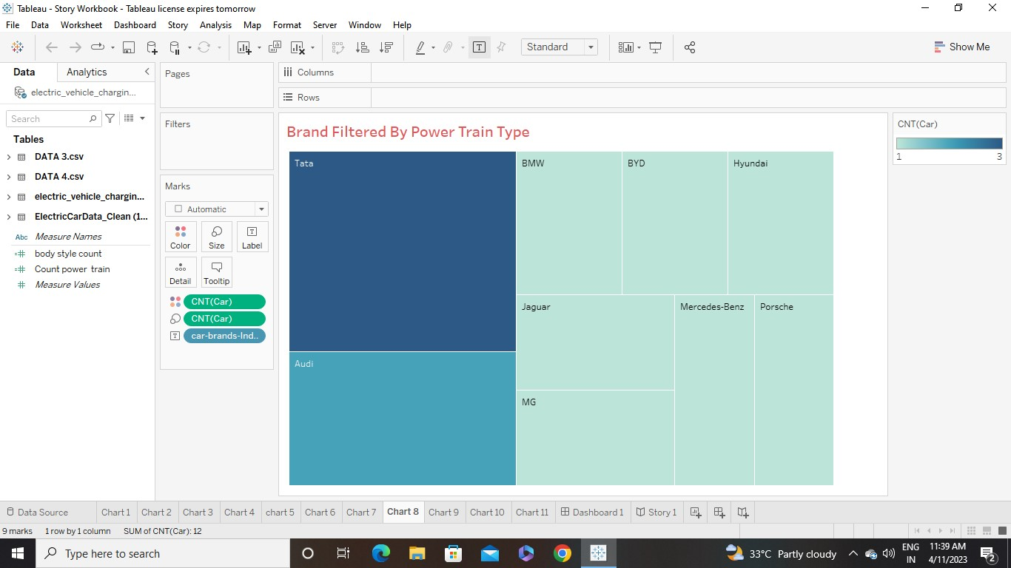

In this chart we filtered the brands according to the type of Power train . Basically, there are three types of Power Train.

9 No of Models by each brand
In this chart, we create the calculation field to have a count of power train and filter the brand according to Power train type and we create the Pie Chart. The below Pie Chart shows the No of models by each brand

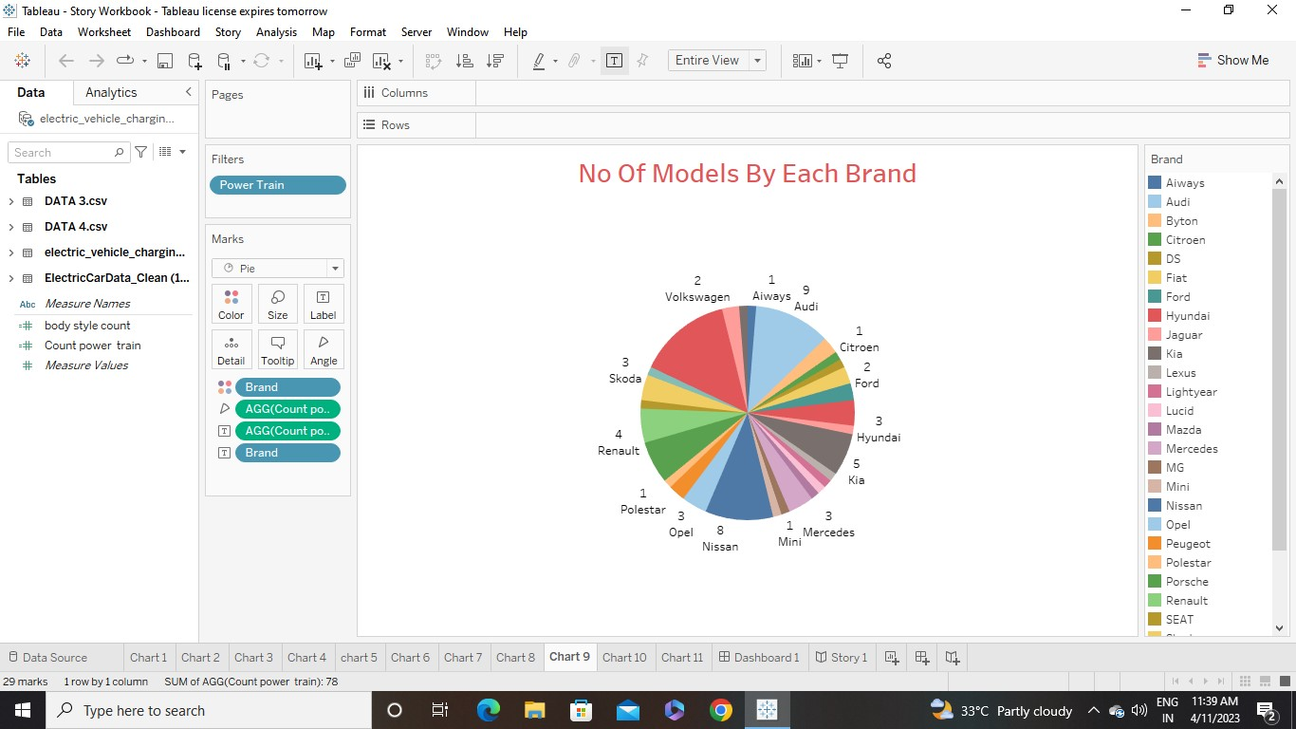

10 Summary card for Different brands of EV Cars globally
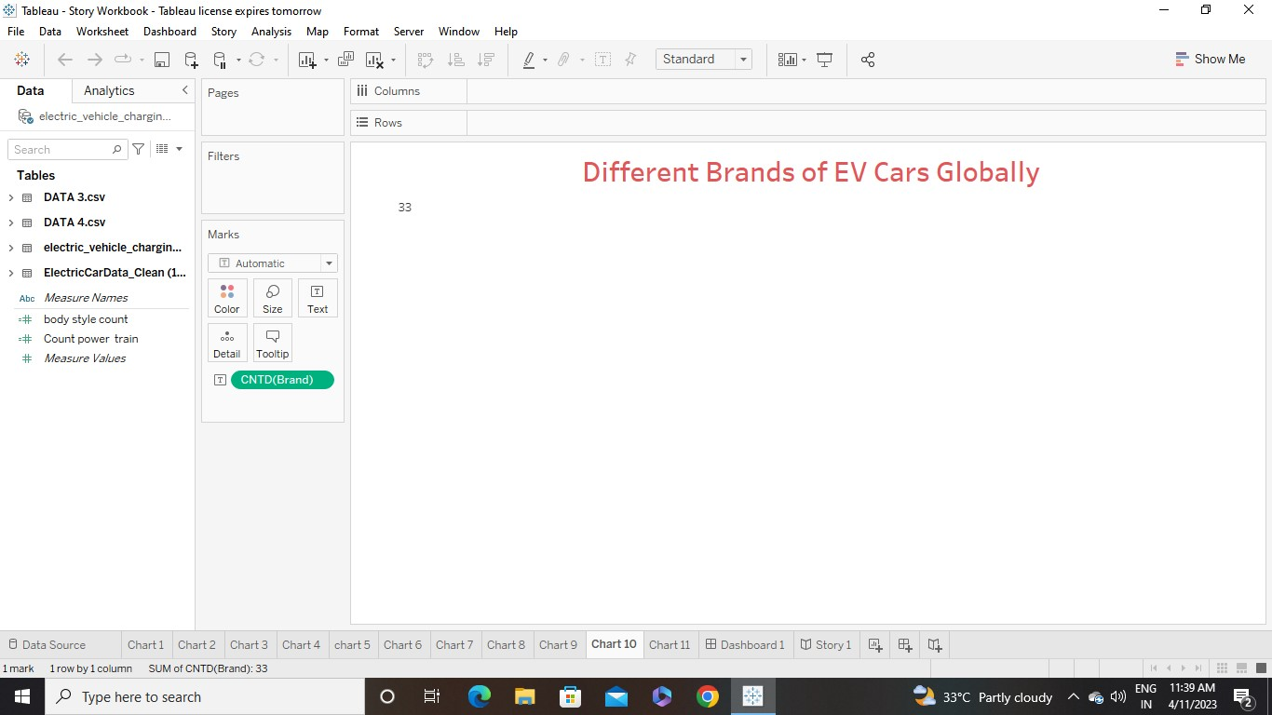
The above visualization chart shows that, there are 33 different brands of Electric Cars are in Globally

11 Summary card for different brands of EV Cars in India
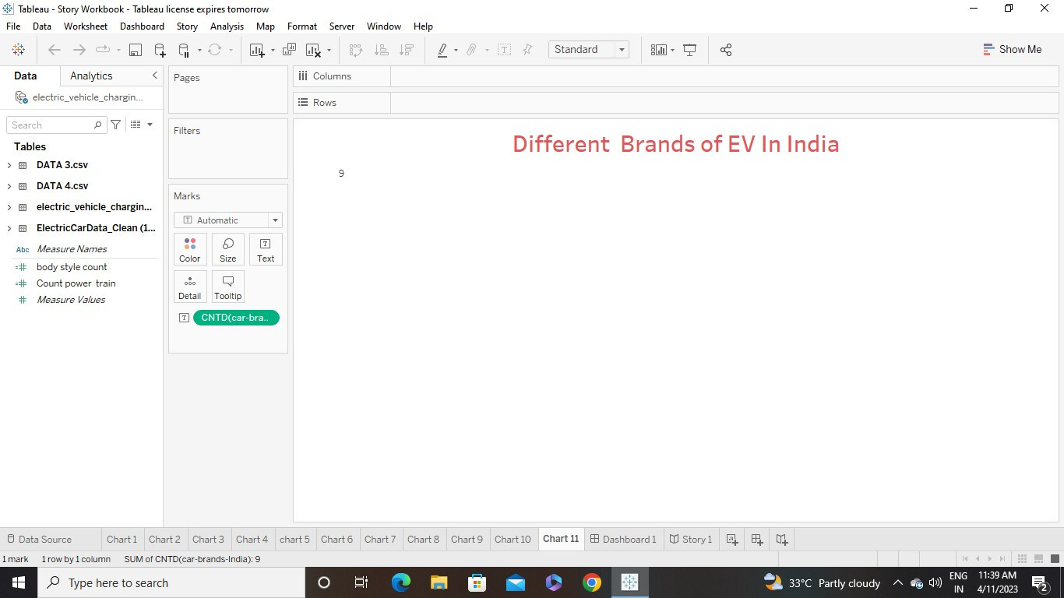
The above visualization chart shows that, there are 9 different brands of Electric Cars in India
DASHBOARD

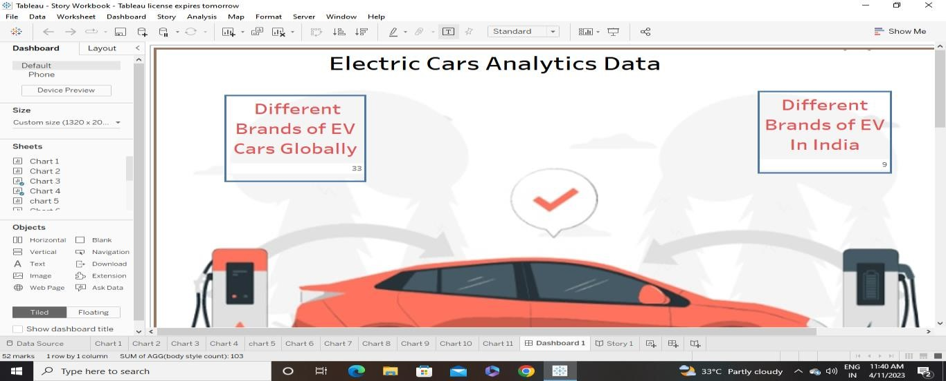
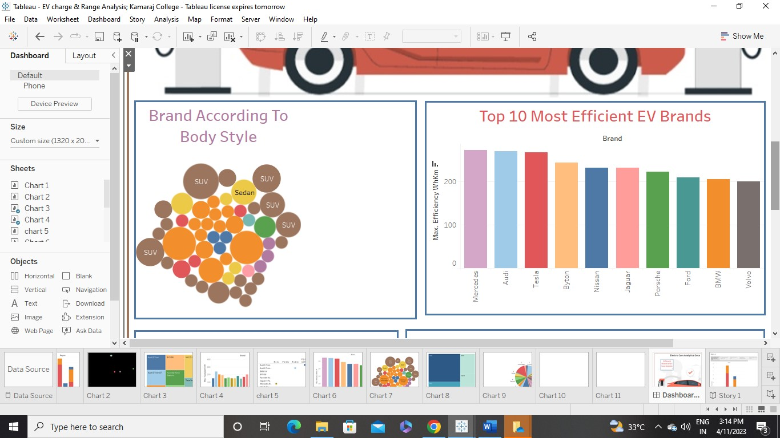

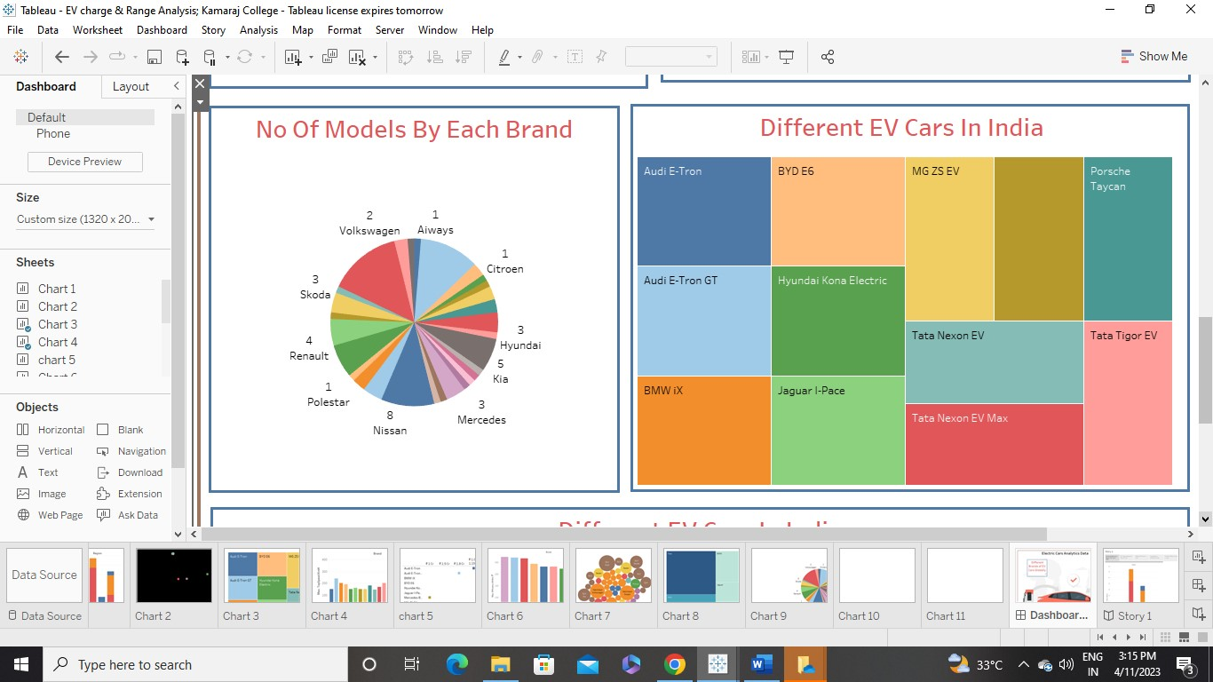
APPLICATIONS
- Consumer Electronics
- Public Transportation
- Aviation
- Renewable Energy Storage
- Military
- Spaceflight
- Wearable Technology

ADVANTAGES AND DISADVANTAGES
ADVANTAGES
- Eco-friendly : Because electric vehicles do not utilize fuel for combustion, there are no emissions or gas exhaust.
- Renewable Energy Source: Electric Vehicles run on renewable power
- Less noise & smoother motion: Driving an electric car is significantly smoother
- Cost Effective
- Low maintenance
- Government Support

DISADVANTAGES
- High Intial Cost : Electric Vehicles continue to be quite expensive
- Charging station limitations
- Recharging takes time
- Limited Options : there are not many electric car models to pick from in terms of appearance,
- Style, or cuustomized variations
- Less driving range
CONCLUSION:
Although electric vehicle manufacturers must solve the hurdles that are currently preventing People from purchasing, the future is clear : EVs will outlast gas-powered automobiles in the long run.
Both GM and Nissan declared in January 2021 that they will go all-electric by the 2030s. Other Automakers will undoutedly follow suit
FUTURE SCOPE:
The future Scope of Electric Vehicle is therefore enormous. We have already seen that
Technology for these vehicles is here and becoming for more advanced. We now know that such vehicles Can provide us with great felxibility and we will soon see that potential. It will also be interesting to see the impact of regulations which will come into force from the EU and US. These regulations are see to reduce their use petrol engine vehicles use. As electric vehicles grow in popularity, so will the need to reduce their use. It is clear that there will be a need to develop new zero emission technologies. India is the world’s third-largest EV market . This competitive market which grew by 23% in 2022, is set to transform the Indian automative sector in 2023. During the union budget for the fiscal year 2023-2024, the Finance Minister allocated Rs 35,000 crore to achieve net-zero carbon emission by 2070.
APPENDIX
Links:
Demo Video Link:
https://drive.google.com/file/d/1bscOmlxHkEm0-hKcsToINKpzc6oOq9l4/view?usp=sharing
Tableau Dash Board Link:
https://public.tableau.com/app/profile/avanigadda.sayal/viz/Electricvehiclesanalytics/Dashboard1
Tableau Story Link:
https://public.tableau.com/views/Electricvehiclesanalytics/Story1?:language=en-US&:sid=&:redirect=auth&:display_count=n&:origin=viz_share_link

